1. Make a list of functionalizes of the database (and software) for Northwind

A list of functionalities of the database Northwind:

* Suppliers: Suppliers and vendors of Northwind
* Customers: Customers who buy products from Northwind
* Employees: Employee details of Northwind traders
* Products: Product information
* Shippers: The details of the shippers who ship the products from the traders to the end-customers
* Orders and Order_Details: Sales Order transactions taking place between the customers & the company

1. Draw the ER diagram for Northwind database

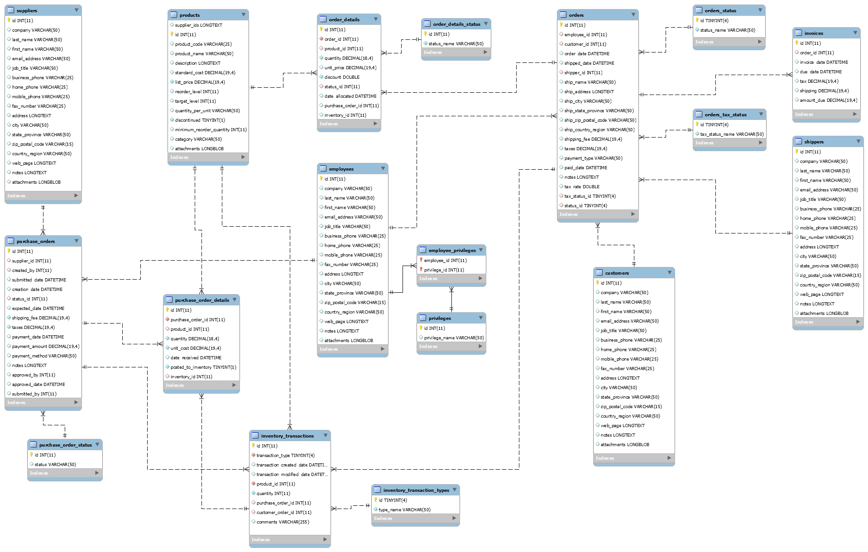

1. Convert ER diagram to a database schema and compare it with the model database of Northwind

customers(id, company, last_name, first_name, email_address, job_title, business_phone, home_phone, mobile_phone, fax_number, address, city, state_province, zip_postal_code, country_region, web_page, notes, attachments)

employee_privileges(employee_id, privilege_id)

employees(id, company, last_name, first_name, email_address, job_title, business_phone, home_phone, mobile_phone, fax_number, address, city, state_province, zip_postal_code, country_region, web_page, notes, attachments)

inventory_transaction_types (id, type_name)

inventory_transactions(id, transaction_type, transaction_created_date, transaction_modified_date, product_id, quantity, purchase_order_id, customer_order_id, comments)

invoices(id, order_id, invoice_date, due_date, tax, shipping, amount_due)

order_details(id, order_id, product_id, quantity, unit_price, discount, status_id, date_allocated, purchase_order_id, inventory_id)

order_details_status(id, status_name)

orders(id, employee_id, customer_id, order_date, shipped_date, shipper_id, ship_name, ship_address, ship_city, ship_state_province, ship_zip_postal_code, ship_country_region, shipping_fee, taxes, payment_type, paid_date, notes, tax_rate, tax_status_id, status_id)

orders_status(id, status_name)

orders_tax_status(id, tax_status_name)

privileges(id, privilege_name)

products(supplier_ids, id, product_code, product_name, description, standard_cost, list_price, reorder_level, target_level, quantity_per_unit, discontinued, minimum_reorder_quantity, category, attachments)

purchase_order_details(id, purchase_order_id, product_id, quantity, unit_cost, date_received, posted_to_inventory, inventory_id)

purchase_order_status(id, status)

purchase_orders(id, supplier_id, created_by, submitted_date, creation_date, status_id, expected_date, shipping_fee, taxes, payment_date, payment_amount, payment_method, notes, approved_by, approved_date, submitted_by)

sales_reports(display, title, filter_row_source, default)

shippers(id, company, last_name, first_name, email_address, job_title, business_phone, home_phone, mobile_phone, fax_number, address, city, state_province, zip_postal_code, country_region, web_page, notes, attachments)

strings(string_id, string_data)

suppliers(id, company, last_name, first_name, email_address, job_title, business_phone, home_phone, mobile_phone, fax_number, address, city, state_province, zip_postal_code, country_region, web_page, notes, attachments)